BENNERY LAKE WATERSHED
MANAGEMENT COMMITTEE
Meeting Minutes

September 12, 2019 – 2:00 p.m.
2 Park Ave., Lower Sackville – Halifax Water Office Boardroom
Attendance:
Barry Geddes (BG) (Chair), Watershed Manager Halifax Water
Jan Jachimowicz (JJ) .Landowner Representative
Dawn MacNeill (DM), Watershed Planner Nova Scotia Environment (NSE)
Anna McCarron (AM), (Secretary), Source Water Planner Halifax Water
Heather O’Keefe (HO), Protected Areas…………………………Nova Scotia Environment (NSE)
Garry Oxner (GO), Superintendent of Water Supply Plants Halifax Water
Paul Parusel (PP), Brookhill Estates Community Representative
Regrets:
Trevor Creaser (TC) (Vice-Chair), Subdivision Approvals Halifax Regional Municipality (HRM)
Reid Campbell (RC), Director of Water Services Halifax Water
Bernie Matlock (BM), P. Eng. ...Nova Scotia Environment (NSE)

Attendance / Introductions:
- AM distributed:
        - Meeting Agenda;
        - Draft March 28, 2019 Meeting Minutes; and
        - Bennery Lake WSP Access Road Realignment and Improvements Drawings.

Meeting Called to Order by Chair (BG).
- Regrets expressed (listed above);
- Quorum noted; and
- Agenda accepted with an addition to New Business – Tour of Bennery Lake Watershed Area.

Review and Approval March28, 2019 Meeting Minutes

Previous Action Items correspond with current Agenda Items; and
GO Moved to Approve Minutes; seconded by JJ; all in favour.
Old Business:  Private land logging violation in PWA update (BG):  - this is an ongoing legal case; and  - decisions regarding this item will be shared with the Committee when they have been determined.  Action: Report to Committee when all aspects of this case have been determined.  Q: When it is settled will it be made public? (HO/DM)  A: Once settled, public notification is expected to be released for education/awareness purposes. (BG)  - The logging contractor aspect of this case was settled out of court;  - the court ordered the contractor responsible for harvesting the trees to compensate Halifax Water the value to remediate the lands. The funds received were set aside for future forestry silviculture purposes;  - this case got other landowners’ attention;  - the point of pursuing this case is to demonstrate that there is a process to follow, not that development is not permitted.  PWA Signage update:  - 2 regulatory signs were placed at the entrances of two separate trails off the reservoir road, which have been providing avenues for all terrain vehicle (ATV) traffic to travel inside the Protected Water Area (PWA);  - a third sign was placed by BG on the water supply plant access road gate off Highway 102;  - these signs have been installed to inform the public about the regulated area;  - video surveillance cameras also have been installed and signs alerting the public to this fact have been posted; and  - most of watershed area access points have been covered with the signage.  Access Road Update:  - The chosen access road design (Item 1.iii) is the existing pipeline road;  - infill will be required to get the 15% grade out of a section of the road;  - a new section of pipeline will be inserted along the infilled portion of road, built to a higher grade;  - asphalting the road to avoid using road salt, which is not permitted in the watershed area, is being considered;  - the old (current) access road will return to nature;  - Halifax Water does not own the current road;  - upgrading the pipeline road is more expensive, but the benefits justify the cost:  - provides improved power and security as well as much improved safety for staff and delivery vehicles currently entering/exiting through the gate directly off the Highway102 to; and  - increases the presence around the reservoir, providing more eyes and ears along that road and around the infrastructure.  Q: What is the timeframe on the new WSP access road?  A: It has gone into Capital Expenditures for 2020.  Increase in ATV Traffic:  - Bennery Lake watershed landowners observe that approximately 30-40% of the ATV activity has been over frozen water bodies;  - a new property owner has been accessing the PWA on his ATV on his own land (which is permissible) and has been issued a key to go through the gate rather than around it;  - as new roads are built, signage will be erected as and where needed;  - upgrading the property boundary and installation of video surveillance has helped curtail ATV activity by outside users already; and  - ATV traffic is a constant battle, but after the new road is built and accompanying gates are constructed, ATV traffic will be further curtailed.  Action: Remove item from agenda.  New Business:  Send JJ a picture of the Nature Reserve, where it is and where it overlaps the Protected Water Area (PWA).  Correction for SWP Report: Item #4 re file # 21707 should be referred to as a “Subdivision” file number rather than a “Case” number; the latter being how planning cases are referred to, not subdivisions. (TC)  Aerial Tour of Watershed Area:  Q: Would the Committee like to have an aerial tour of the watershed area?  A: Yes.  Action: DM and HO to arrange a tour of the watershed area.  Municipal Planning Update:  Oakfield Estates Subdivision File# 21707:  BG displayed a wet areas map of the proposed subdivision development (see Appendix 1).  - The plan meets requirements for setbacks, lot size, and bylaws;  - wetland areas inside the proposed development area were overlooked – there is a significant wetland that has been identified in the plan and another one that has not been;  - these wetland areas are Wetlands of Special Significance (Objective 1) per the Nova Scotia Wetland Conservation Policy;  - the purple area on attached map is the proposed subdivision development area, which is situated inside the PWA;  - these are as-of-right developments in consideration of the Bennery Lake PWA;  - even though the development is as-of-right, provincial regulations trump municipal bylaws;  Q: How many houses are in the proposed development? (GO)  A: 60 in Phase 3B plus 10 in Phase 3A. (BG/AM)  - road frontage is outside the watershed;  - if the wetland isn’t built on, there isn’t an issue;  Q: Will they have their own water and on-site septic? (GO)  A: Yes. Our comments recommend septic systems be situated outside the PWA. (BG)  Q: Will drilling into that aquifer affect the lake? (GO)  A: There have been discussions on this. (BG)  Q: Is there a timeframe in which you must build? (GO)  A: Tentative approval (in subdivisions where new roads are built) is valid for 2 years. A question for TC. (BG/AM)  - 10% of the of total area of the lots being created must be deeded to HRM for parkland, or cash in lieu;  Q: Are they leaving room for a pipeline for water service? (GO)  - additional comments regarding wetlands and setbacks from them, are additional to those already circulated;  - a “K class” road (an old post road, which belongs to NS Transportation and Infrastructure Renewal) goes through the proposed subdivision;  - built in 1799 – part of old road to Truro;  Q: For that subdivision development, is the response from Halifax Water to HRM planning considered to be written approval for permitting the construction of a development? (DM)  A: Yes. (BG)  Q: Could you stipulate that homes cannot have oil heating? (GO)  A: If it is not a regulatory constraint, then it would be OK to include it as a recommendation in the letter. However, you could make it a regulatory requirement if you wanted to. (BG /DM)  Q: Once the subdivision is approved, do we get any more comment after that? (AM)  A: Every development application, as well as an erosion and sedimentation control plan require review by Halifax Water before approval. (BG)  - the Committee can recommend no oil tanks, but we cannot stop them from installing them; however, we could request a change to the PWA regulations stating the oil tanks are not permitted;  - Halifax Water practices, as its first line of defense to reduce risk to the PWA, purchasing properties in it, when given the chance, at market value;  - we recommend leaving the regulations alone;  - a gasoline tank or transfer of fuel from tank to tank, 100 m of the shore or watercourse (not a wetland), is currently not permitted;  - BG will circulate a letter with comments to the Committee for their review.  Action: Construct a letter and circulate to members for input/approval.  Landowner Q&A:  - a landowner asked BG if it was OK to spray their PWA property for ticks;  - BG advised them no, and to stop feeding squirrels and deer, which carry ticks;  - A new house is being erected in the PWA – it is roof tight;  - BG was not aware and not notified of the permit to develop;  - BG will visit the property owner; and  - there should have been a letter of approval from Halifax Water.  Action: BG to follow up with TC to see why Halifax Water was not advised of that house development.  Education and Awareness:  Action: AM to create a template of education and awareness information for distribution as needed and tailored to various situations.  - idea is to create a package to update and educate homeowners about PWA;  - currently, land purchasers and homeowners may or may not be aware of the regulations when they purchase their property;  Q: To PP: Did you know about the regulations when you bought your property? (AM)  A: We had no idea that we bought in a PWA nor the meaning of the regulations. The real estate company did not mention the restrictions.  - this indicates that we need to bridge the divide regarding education and awareness for landowners;  - there are only 15 homes – plus – in the PWA that need education;  - need to consider how much bang we are getting for our buck;  - currently we have a sign and PP to educate the community;  - existing sign does not tell everyone where the PWA is.  - consider an interpretive sign with a map by the mailbox;  Q: Is there an emergency and “for more information” (FMI) number on the existing sign?  A: Yes…on the 4 ft x 8 ft sign.  - Viewpoint realty website may be a useful tool to help get the message out:  BG displayed Viewpoint for the Committee to explore.  - The data on Viewpoint regarding Wilderness Areas is old;  - Open Data has the most recent protected areas on it;  - could ask Viewpoint to update their data;  - only people who want to buy properties are going to Viewpoint.  - need to explore options further.  Action: NSE will contact Viewpoint about posting where watersheds and other areas are.  Election of Officers – October 2019  Action: Ask TC if he would like to be Chair for this term. If he is willing, then we vote in favour.  Next Meeting Date:  - March 5, 2020 at 2:00 pm.  Adjournment:  Motion to adjourn the meeting: 3:58 pm (JJ)  Respectfully submitted – AM | Action  BG/TC  Action  AM  Complete  Complete  DM/HO  Action  BG  Action  BG/TC  AM  DM/HO  All

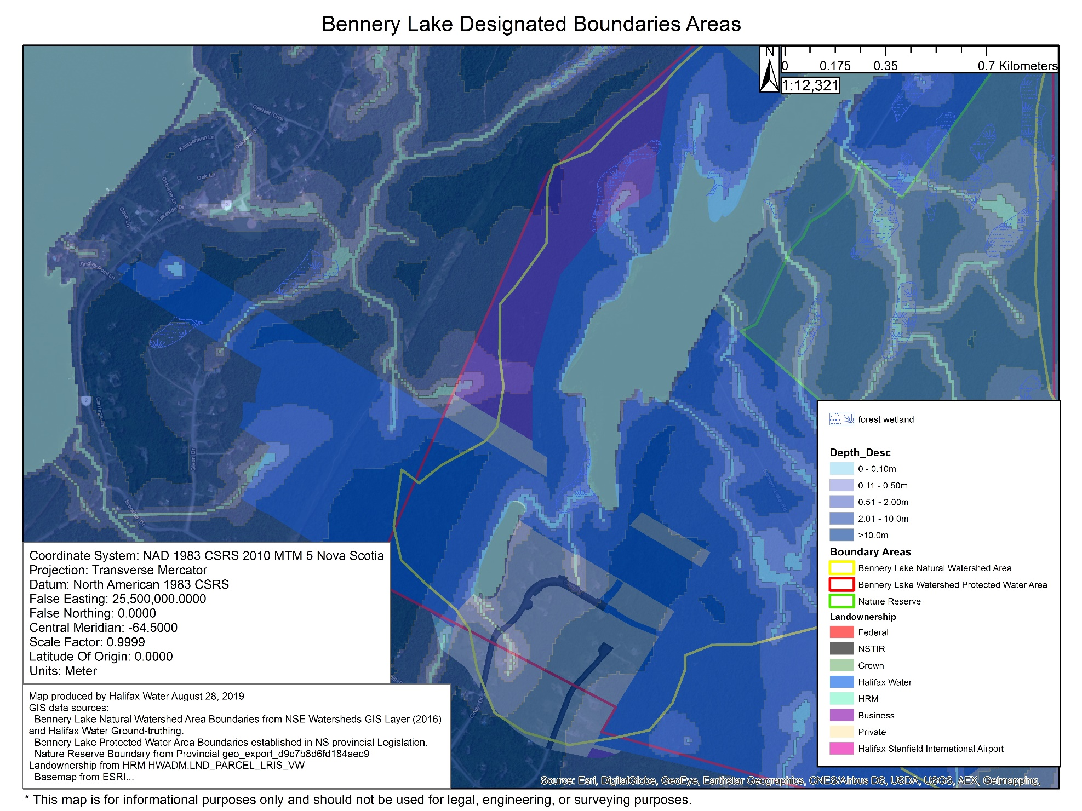
Appendix 1: Wet Areas Map Around South Sections of Bennery Lake Watershed Areas

